Curriculum Vitae
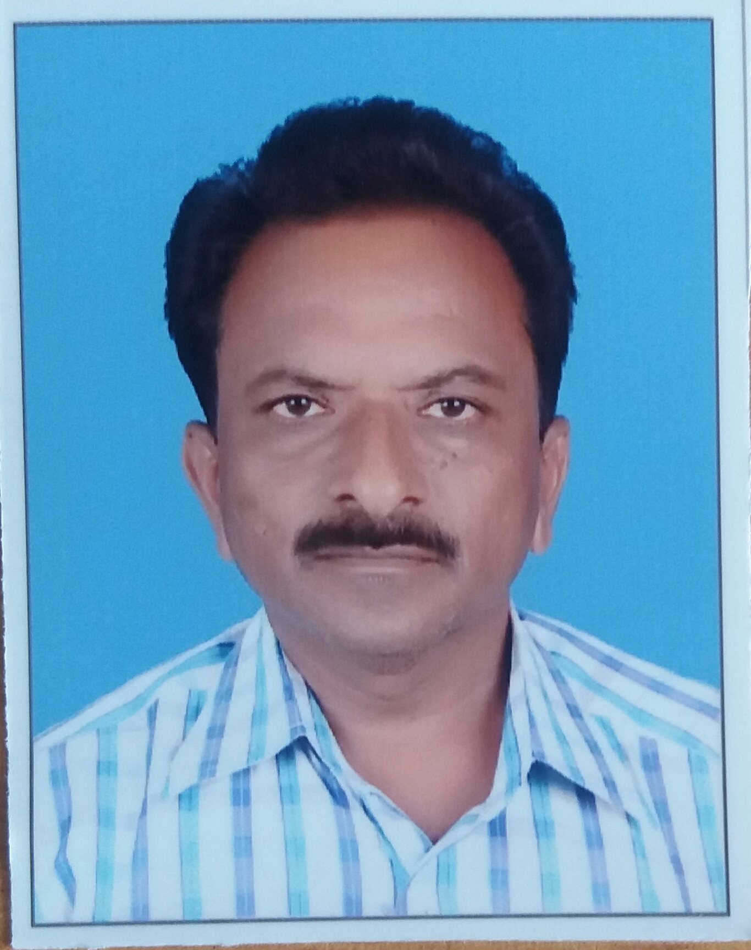
Name: Mr. Hake Maruti Ananda
Shivaji Nagar, Sangola,
Near ZP School,
Tal- Sangola,
Dist- Solapur (MH), India
Pin Code- 413 307
Mobile: +91-9823565417,
E-mail: hakemaruti123@gmail.com ,
Date of birth: 01/06/1968,
Nationality: Indian

Office Address:
Vidnyan Mahavidyalaya, Sangola.
Tal: Sangola, Dist: Solapur (MH)
Pin code: 413 307

GENERAL INFORMATION:
1) Sex: Male
2) Marital status: Married
3) Career Objective: Research and Teaching
4) Languages Known: English, Hindi and Marathi
5) Hobbies & interests: Reading

EDUCATIONAL QUALIFICATION
Exam.  Passed | Year of Passing | Board / University | Subject Offered | % of Marks | Remark
Ph.D.# | 2012  (Registered) | Shivaji University, Kolhapur | Botany | -- | Registered
M. Sc. | 1993 | Shivaji University, Kolhapur | Botany | 60 % | First class
B.Sc. | 1991 | Shivaji University, Kolhapur | Botany | 75 % | First class
- Teaching experience:
- Worked as “Assistant Professor” at Vidnyan Mahavidyalaya, Sangola During 1993 to 2014.
- Working as “Associate Professor”, at Vidnyan Mahavidyalaya, Sangola, since 2014.

- Particulars of Orientation Programme/Refresher courses attended:

Year | Name of Academic Staff College
2015 | Refresher Course: Academic Staff College, Sant Tukadoji Maharaj Nagpur University, Nagpur
2014 | Refresher Course: Academic Staff College, Sant Gadage Baba Amaravati University, Amaravati
2012 | Refresher Course: Academic Staff College, BAMU, Aurangabad
1997 | Orientation Programme: Academic Staff College, Pune University Pune

- Participation in National/International Conferences /Seminars/ Workshops
[1] | One day seminar on Human Rights and Duties of Education organized by Vidnyan Mahavidyalaya, Sangola on 3rd March, 2016
[2] | State level Seminar on Recent Trends in Plant Sciences and Agricultural Research organized by Sangameshwar College Solapur and M.P. Krushi Vidyapeeth, Research station Solapur on 23rd January 2016
[3] | One day state level seminar on Medicinal plants and plant pathology for B.Sc. students organized by Sangola College Sangola on 09th February 2016.
[4] | Participation in Programme on Biological Terminology in regional language organized by Sangola College and Ministry of HRD, Dept. of Higher Education on 24th July 2014.
[5] | National Conference on Frontiers of Plant Science for Sustainable agriculture and rural development organized by ASC college Naldurga Dist-Osmanabad (MH) on 28th and 29th January, 2011
[6] | Seminar on B.Sc.-III Botany organized by Shivaji University, Kolhapur on 5th June 2011.
[7] | National conference on Plant Biodiversity organized by Yashvantrao Chavan Institurte of Science Satara on 23rd and 24th April 2010.
[8] | International Symposium on the New Horizones organized by Department of Botany, Shivaji University, Kolhapur on 10th Nov. to 12th Nov. 2010.
[9] | State level seminar on Advances in Biotechnology organized by KBP College Pandharpur on 13th-14th February 2009
[10] | Workshop on New Syllabus B.Sc-I and II organized by Vidnyan Mahavidyalaya, Sangola on 9th January 2009
[11] | One day seminar on traditional syllabus organized by Sangola College , Sangola on 7th Sept. 2008
[12] | Workshop on UGC syllabus Botany B.Sc.-III organized by Y.C. college Warana on 13th – 16th Sept.2005
[13] | State level seminar on Botany and Industry organuised by Shivaji University, Kolhapur on 21st February 2004
[14] | Workshop on B.Sc-I Botany syllabus organized by New College, Kolhapur, SU Kolhapur on 17th Sept. 2003
[15] | Workshop on Botany organized by ASC College Lonand on 27th Dec. 2002

- Membership
- Member of Solapur University Teacher’s Association.
- Guest Lectures:
- A lecture is delivered on “Environmental Hot Spots in World”, at Staff Academy, Vidnyan Mahavidyalaya, Sangola.
- Other Activity
- N.S.S., Programme Officer (From 15th July, 2004 to 10 October, 2012)
- Worked as examiner at Science exhibition organized by Sangola College Sangola on 9th February 2016.
- Worked as member of “Examination Committee”.
- Worked as member of “Vidnyan Mandal”,
- Worked as “Jr. Supervisor, Sr. Supervisor, Paper setter and Moderator” for theory examination of Solapur University, Solapur.
- Worked as “External & Internal Examiner” for practical examination of Solapur University, Solapur.

